Online Presence Builder

Overview

Contents
Messaging 2
Quick Pitch 2
Top-line Benefits 2
Detailed Benefits 2
Features 4
Features Overview 4
Supported Gateways/Payment Processors 5
Customer Experience 7
Sales Support 13
Probing Questions 13
Selling Points 13
Objection Handlers 15
Frequently Asked Questions 17
General 17
Management & Installation 20
Plans & Pricing 21
Payment Integrations 21
Shipping 21
Full Feature List 24

Messaging

Quick Pitch
81% of Internet users research products online before they make a purchase. It’s more important now than ever for businesses to have a credible and trustworthy online presence.
Businesses can create a website that is right for them and it’s optimized to look great on any device.
Online Presence Builder is an easy-to-use design tool that allows anyone to build and maintain beautiful, mobile friendly websites that engage and attract customers.
Create an effective online presence with an easy-to-use visual editor, drag and drop design tools, engaged design themes, custom domains, hosting and mobile optimization. It’s never been this easy to look great online.

Top-line Benefits
- Made for everyone: Our Drag and Drop editor allows users to easily create a website and even create a One-Page Website with a few clicks.
- Modern designs: Choose from engaging, SEO-friendly website themes that automatically look great on desktop, mobile and tablet devices.
- Engaging website elements: Add personality to a website. Easily add photo galleries, videos, buttons, Facebook and Twitter widgets, contact forms, appointment scheduling, Google maps, tables, lists and more.
- Add pages and layouts: Easily add multiple pages with different layouts such as galleries, menus, FAQ and more.
- Professional, modern images: Access a full gallery of modern, professional stock images, ready to use on a website, plus easily edit any photos with the built-in Image Editor.

Supporting Statistics
- Get found where customers are searching. 81% of internet users research products online before they make a purchase. (GE Capital Retail bank)
- If businesses not online, potential customers will find their competition. 71% of small businesses have a website. If businesses do not have a website, their customers will find another business that offers the same products and services that also has an online presence. (Forbes, 2023)
- A website ensures success. Over 90% of people are online, without a website a business is invisible to these people (Themeisle, 2022)

Detailed Benefits

Modern, Engaging Design Themes | - Fresh, responsive design themes.  - Automatically optimizes the website across devices, including desktops, tablets and smartphones.
Cost Effective | - Get all the key features needed to build, market and manage a website at an affordable price.
Professional Images | - Personalize a website with a gallery of free, modern stock photography.  - Image galleries are a necessary component of almost any professional looking website. Easily add and manage images on a website in six different gallery formats.  - A built-in photo editor makes it easy to crop, resize and retouch images on a website for the perfect look and fit.
Social Media & Widget Integration | - Increase website visibility. Integrate Twitter, Facebook, Google Maps and YouTube widgets.
Drive the Right Behavior | - Business owners can easily create different types of web forms that can help them interact with their site visitors or gather user information.  - Create custom Call-to-Action buttons directly within the Online Presence Builder.
Add Unlimited Pages | - A website that grows with a business. Easily add, delete, and edit pages, such as menus, portfolios and more!
Easy Management | - Business owners can access an intuitive online dashboard to manage their online presence, domain, and other services.  - View website analytics, including traffic, clicks and most popular pages.
24/7 Access | - Manage the website from anywhere that has internet connection.

Features

Features Overview
Online Presence Builder editor | - Instant Online Presence Website  - Sample industry content  - Contact us information pre-populated  - Email contact form auto-generated  - Intuitive, user-friendly editor, with drag-and-drop visual editing.  - Add in text blocks, images, image galleries, buttons, lead forms, videos, lists, menus, customer quotes, Google map, social media widgets and more.  - Embed HTML code.  - Add as many additional pages as needed.  - Hover help tips and tricks.  - Preview the site in desktop, tablet and mobile views.
Design Themes | - Modern design themes mobile optimized for tablets and smartphones.  - Hero images with slideshow support, and pre-formatted royalty-free image selections.  - Change the design theme at any time.  - Customize the fonts and color scheme.
Elements | - Drag and drop in pre-formatted blocks for headings, text, images, text links, image & text combinations, HTML snippets and block quotes.  - Add sleek image galleries in different layouts: classic, slideshow, filmstrip, mosaic and slider; add in YouTube videos, with built-in video search.  - Get social by adding a Facebook “Like” button, “Send” button, “Follow” button, Page widget or Facebook comments.  - Add in a Google map and Open Hours for the business.  - Layout content in columns, rows, collapsible rows, tabs, accordion style rows, and save reusable content.  - Add a lead form, call-to-action, tables and numbered or bulleted lists.
Images | - Access a free gallery of professional, modern images to use on the online presence.  - A built-in photo editor makes it easy to adjust images as needed to boost an online presence’s design:  - Crop, resize, change image orientation, and adjust redeye, focus, brightness, contrast, saturation and warmth.  - Add text, drawings, special effects, frames or stickers.
Site Settings and Pages | - Add Google Analytics, embedded search, overall keywords and meta-description, Header HTML and more.  - Manage all web pages in one simple menu.  - Supports sub-navigation.  - Customize Page Name, URL, keywords and description per page to help in SEO efforts.
Built-in Help | - Business owners can access a built-in resource Support Center for helpful articles on creating, customizing and optimizing their online presence.

Customer Experience
Access Online Presence Builder through the “Websites” tab of the Portal, where customers manage their services. Business owners can select the domain they would like to get started with if they have multiple domains associated to their account.
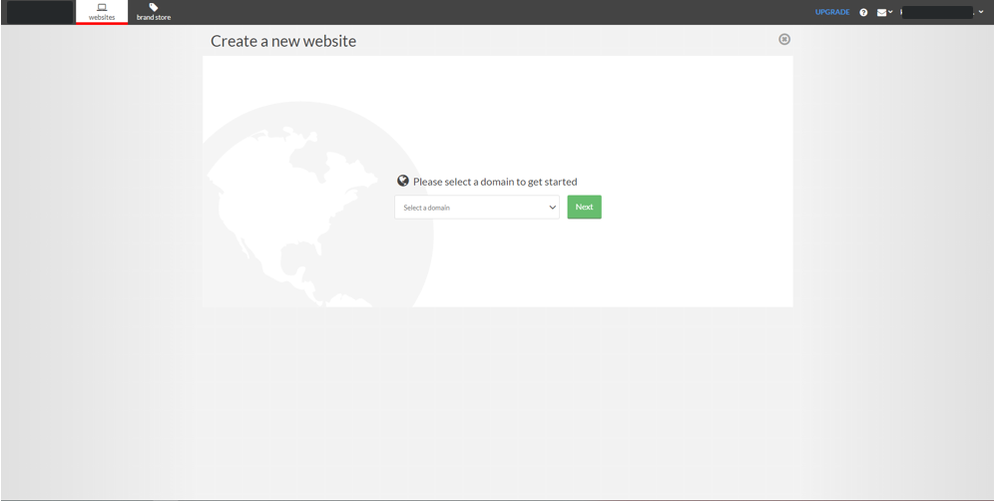

Click on “Get Started” to launch Online Presence Builder
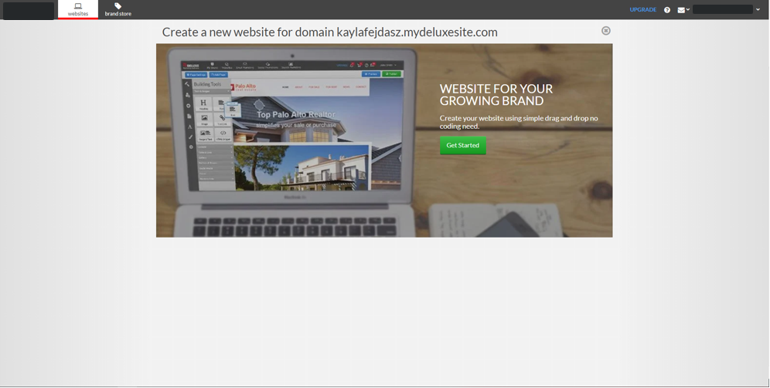

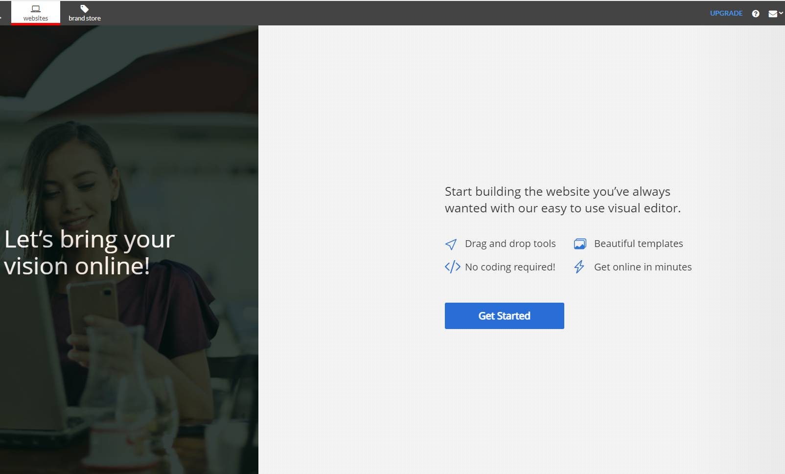
This is the on-boarder, which helps get them started with a simple one-page website to Publish or customize. The first step is to confirm their business details and select a category. Confirm or edit their website name and contact details. These details will be used to generate relevant images, content, a map and contact form.
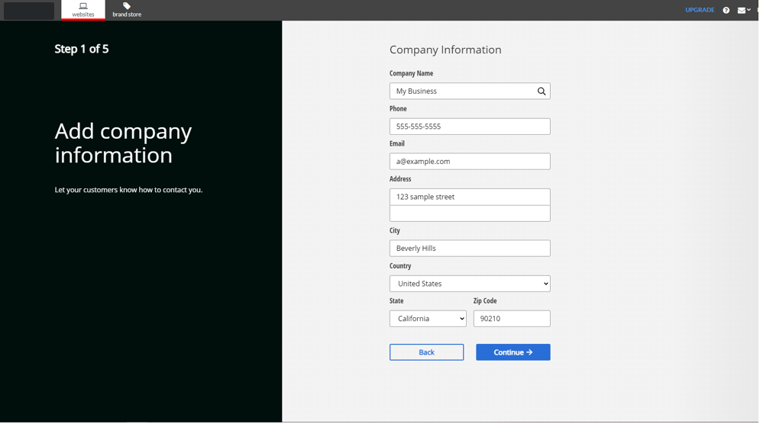

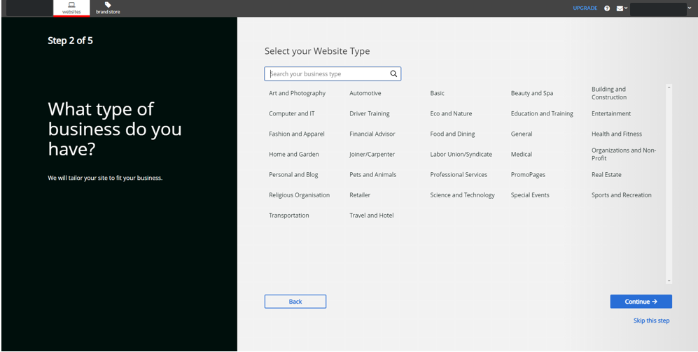

Next, choose a design theme. Customers can change the design theme at any time. Finally, click “Preview”.
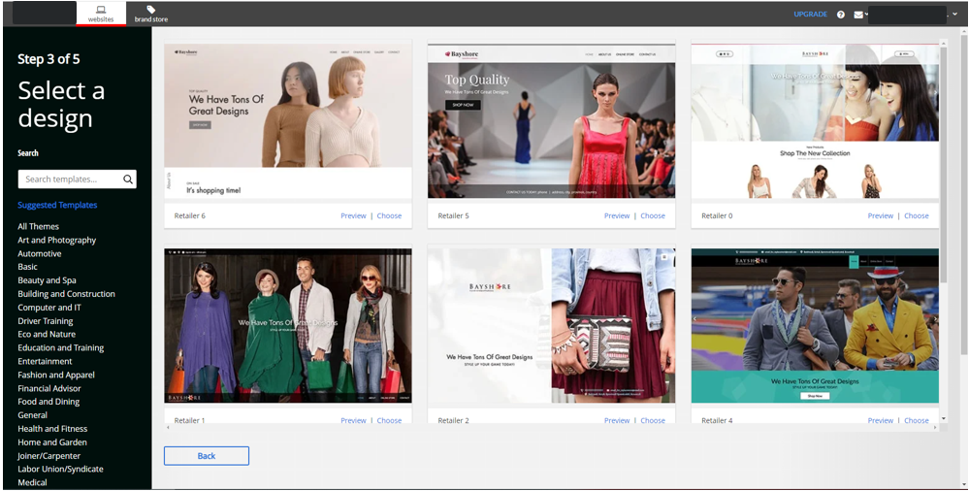

If they have a logo for their business, they can click the logo section to add it. They can edit these details or the logo at any time in the editor.

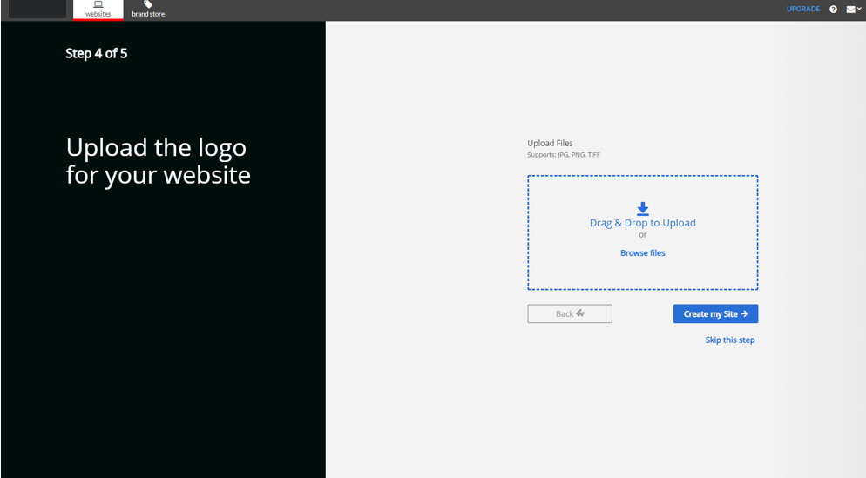

Click create my site and the site will propagate.

They can then access resources for Online Presence Builder that will help them build and edit their site.
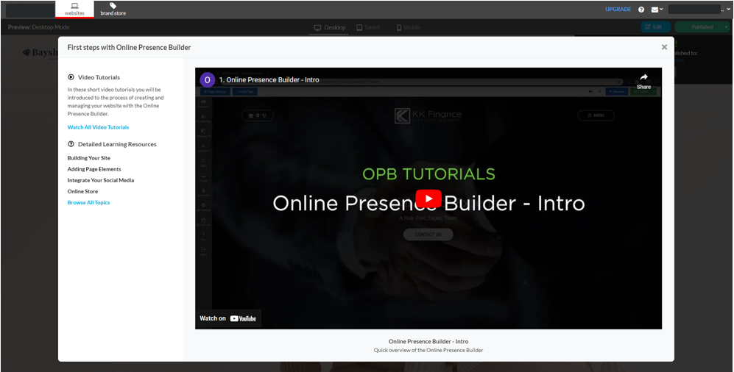

Update Contact information, hours of operation and view announcements.
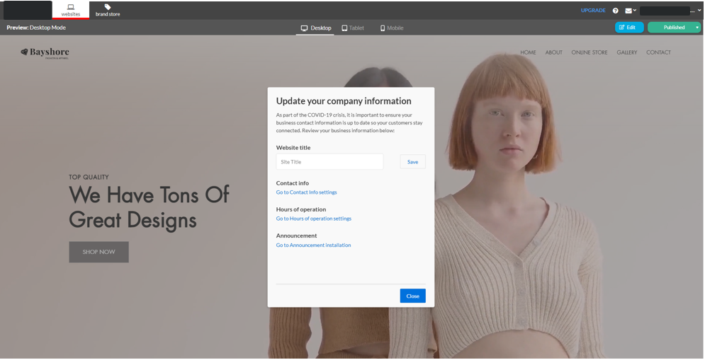
Business owners can toggle between devices to preview their one-page website in Desktop, Tablet and Mobile views. Clicking “Publish” will make the one-page website live. It’s important to get a website online as soon as possible to build credibility with search engines and start building a ranking. Now, customers can edit their website at any time.
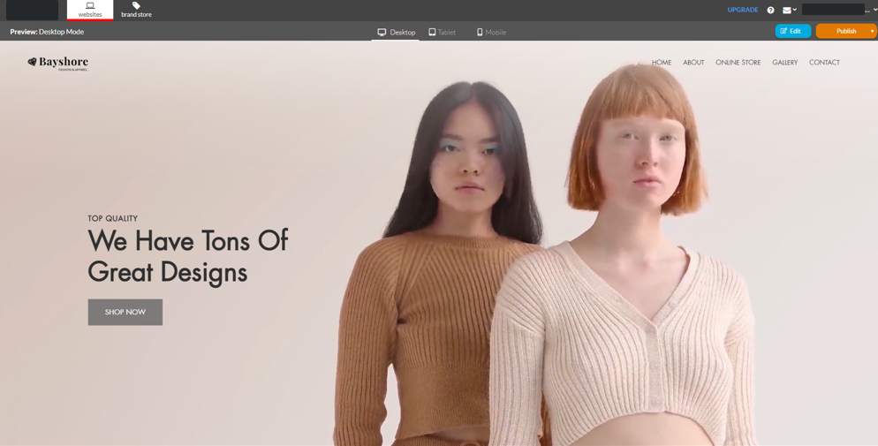

When they select “Edit”, Online Presence Builder’s editing tool will open with their website. This intuitive, drag-and-drop editor has all the easy options business owners need to customize their website: add images, add new pages, edit text, and build a powerful website for their business.
The menu on the left side gives users access to drag and drop different element blocks onto the web page, manage pages, change the design theme, and customize site settings.
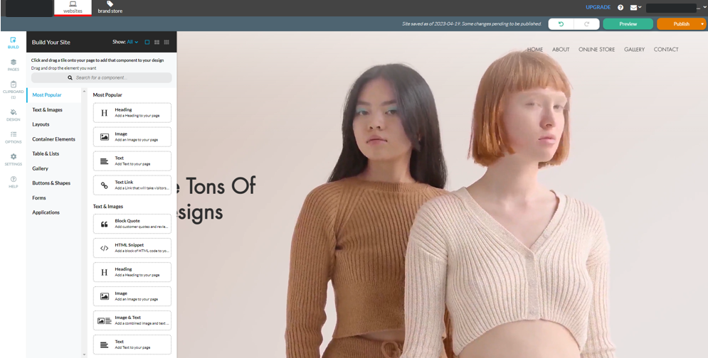

When users select an element on the page, the menu on the right side will open to allow them to edit additional elements on their page. They can also use this to customize, for example clicking on a block of text allows them to input and customize their content.
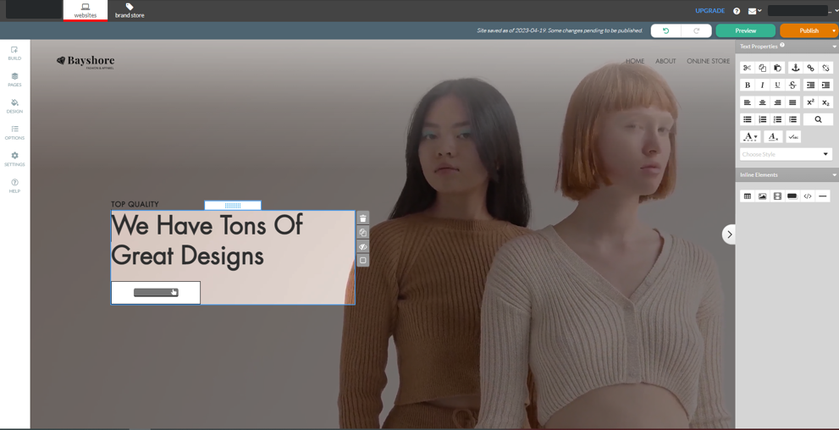

A map will be generated with the business location on the Contact Us page, to make changes on map size, location and alignment click on the map and a menu will open on the right side of the screen.
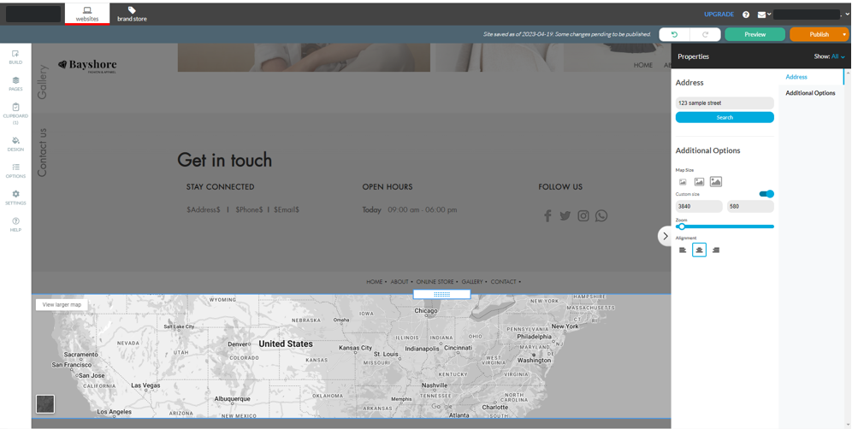

Images and galleries are an important way to showcase the business to website visitors. Drag and drop in a gallery block and click to add/edit images.
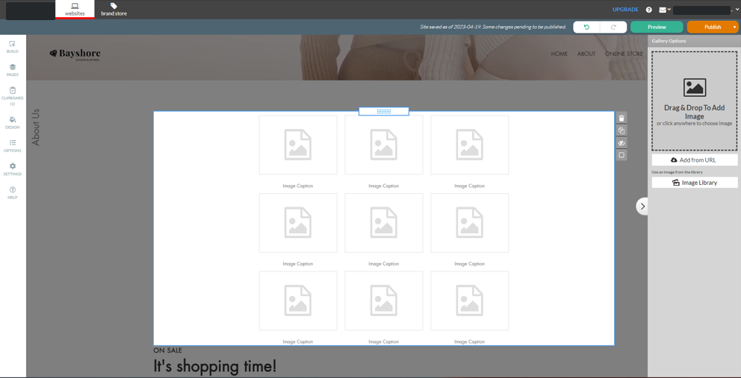
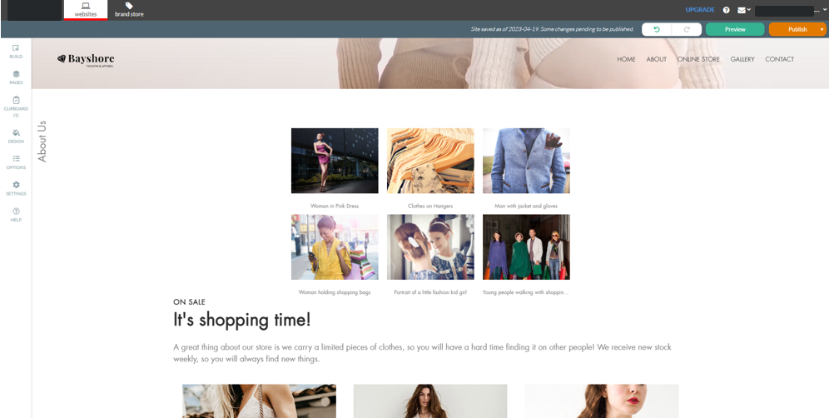

When ready, click Preview to view the website on desktop, tablet and mobile screens.
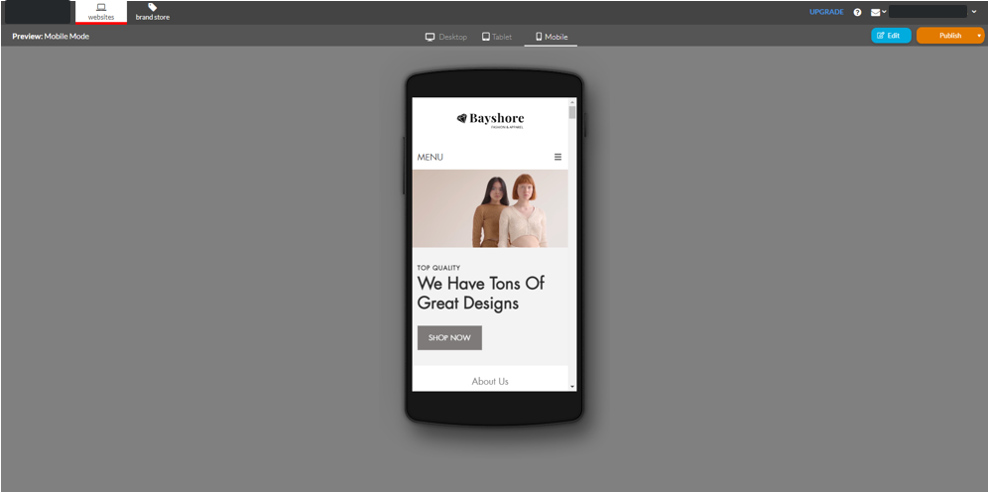

Click Publish to make updates live. And that’s it! There are a ton of options for more customization and site settings. Get started now to explore the full tool and take advantage of a professional, mobile-optimized website for businesses.

Sales Support

Probing Questions
What would happen if I Googled what your business offers, in your city? Would your business show up?
Do you know that 9 out of 10 purchases start online? You need to get found online. You could be losing customers every day to your competitors.
Stop losing business to the competition who are getting in front of your potential customers online. Online Presence Builder allows anyone to build impressive websites that perform on every screen and help you get found online. Plus, a domain and branded email, features that drive your visitors to action, all accessible in one simple interface. Save time and make an impact.
What do you think?

Do you have a website?
- Yes?
  - How could your website be improved: design, mobile-friendly, selling online, attract new customers?
- No?
  - Great, don’t lose any more time waiting! It’s important to have a professional online presence so customers can trust your business’ credibility.
  - Online Presence Builder is a really great, cost-effective way to get started online that won’t take up your time. There’s a two-step on-boarder that produces a fully responsive (meaning optimized for tablets and smartphones) website with your contact info, a Google map and lead form that sends inquires to your email. Then you can add more pages and customize it whenever you decide.

How often are you updating your website?
Websites that are updated between 30-60 days are going to show up higher in search engine rankings because the material is viewed as fresh and up to date. With Online Presence Builder it’s easy to build and make edits to your website.

If you don’t have a website how are promoting your business?
Your website works for you, people can learn about your business even when your storefront is closed. You could be reaching a whole other client base that has yet to know your product/service.

Selling Points
Establish an online presence. Customers are more apt to trust businesses with a professional, up-to-date website. Consumers often use websites to “window shop” and compare products and pricing. Having a professional online store will not only drive online sales for businesses with new customers and new markets but help drive traffic to their business.
Online in minutes. Users just select a design, confirm their business name, contact info and CLICK – they’re online. A two-click set-up creates a landing page website with business details, map and a form to immediately start capturing customer interest. Then, users can start adding more pages whenever they’re ready.
Easy to use. With fresh responsive design themes available in just a few clicks, the Online Presence Builder is ideal for small businesses. Build a website with confidence. Up-to-date content is key to getting found on Google and building credibility with visitors.
Add content, customize text and images, create new sections, all with a new and improved drag-and-drop editor. Log in anytime to make updates on the fly. Users don’t have to be a professional designer or know code to create and manage a website that’ll get them noticed.
Why should I choose Online Presence Builder?
- No technical skills required: drag and drop editor, multiple layout options, social media integrations.
- Access to professional royalty free images.
- Responsive design - looks great and operates on any device.
- Ability to add new pages as you grow.
- Our plans are flexible and affordable and can grow with your business.
- Make your life easier by consolidating all your invoices through one provider.
- We’re a strong, established brand, and we’re not going anywhere.
- We provide more than just hosting or a website, we offer a complete online solution.

Competitive Information
See Competitive Analysis

Objection Handlers
I already have a website / happy with my current provider.
Does your website get found by customers searching online? Does it have an impact on your business and help drive sales and prospects? Does it include marketing tools to help promote your business?

- Our plans include a full offering of marketing tools such as:
  - Email marketing to promote your products or services and drive traffic to your new website.
  - Social media tools make it easy to post one time with one login, to Twitter, Facebook and LinkedIn.
  - Optimization tool with access for optimizing your website for search engines.
  - Website analytics to measure visitors and what pages are most popular.
  - You can also update your plan at any time, so your website can grow with your business – add an online store or upgrade your online marketing.

Your website should do more than be there for existing business, it should help your business get found by new customers.

- Can you easily make changes to your website yourself? If someone else makes changes for you, do they charge and are they able to make changes quickly?
  - All plans provide you with full access to your website. You can access your site anytime with no additional cost.

- Is your website up to date? How up to date is the content and images?
  - Your website represents your business online, and users don’t trust an out-of-date website. You need fresh content to keep interest.
  - New content also helps your search engine ranking so visitors can find your website more easily.
  - Linking to your social media profiles or embedding feeds online also boosts interest and increases traffic to your website.
  - All plans provide you with 24/7access to your website so you can stay up to date.

It’s too expensive/Can’t afford one.
- How many new customers a month would it take to handle the cost?
  - A website is an investment – drive new business and stay competitive.
  - Our plans include more than a website – you’ll get free professional email addresses using your domain; email marketing tools to market and communicate with customers; social media tools, and more.

- How much do you spend on print advertising?
  - More and more customers are turning to the internet to search for businesses – especially local services. To compete, you need to consider how you’re being found.
I don’t need one right now/right away.
- Can I check if your domain name is available? Have you checked to see if your competitors are online?
  - The domain of your choice may not be available later.
  - 71% of businesses already have a website.
  - When you’re looking for a local service or a new product, where do you look? I know if I want to order a pizza, I Google places in my area.
  - Customers expect to find you online – build credibility for your business.
I don’t know how to make a website/ no programming experience.
- Are you comfortable using Microsoft Word or PowerPoint?
  - Start with a template for your industry vertical and just customize content and images.
  - Our simple, drag and drop website creator makes it easy to create and customize your website.
  - We also have Do-it-for-me Professional Design packages.
I don’t have/need a website.
- Customers are searching online for local businesses, at home and on their mobiles. A website will help you reach new customers and grow your sales.
- Having an up-to-date website builds your credibility and professionalism. Customers will trust your brand.
- A good website will lighten your load – providing company information including your hours, contact information, products and services. Reduce repeat calls on general inquiries about your business.
- If you’re not online, your customers could be finding your competition instead.
What about free website providers? Why wouldn’t I just go/stay with them?
- Free sites are limited in terms of features – like having a subdomain instead of your own domain, affecting the image of your business.
- You might have ads on your website, or prominent branding by your provider, also affecting your image.
- Free site providers are constantly hassling you to upgrade to a paid, premium version or add additional features.

Frequently Asked Questions
How do I use the new Online Presence Builder?
Online Presence Builder was built with ease of use in mind. When you first login to your Portal, click on the Websites tab and select Get Started to launch Online Presence Builder. You can select a new design from a selection of brand new, stylish designs created by professionals (and remember you can change your design at any time). Customizing your site is as easy as dragging and dropping your elements onto the page. Select elements from the left-hand menu (for example a heading, text or image), drag and drop it on to your web page, and double-click to edit the element.
We’ve included a user guide to help walk you through the process of upgrading your website using the new Online Presence Builder. For helpful tips on upgrading your website to Online Presence Builder, see our Guide "Upgrading your Existing Website to Online Presence Builder".
Do I need to build a separate mobile site with the Online Presence Builder?
No – Online Presence Builder uses a responsive design to automatically adapt your site to look great on every device: desktop, mobile or tablet. There’s no need for you to spend the time in developing a separate, mobile-friendly site. Your website will automatically adapt to the device your visitors are using, with the important details front and center. When designing and editing your website, you can preview how it looks on a desktop, tablet or mobile view.
Can I change my design once I select it?
Yes, you can change your design at any time. Select “Design” in the tool to view the available designs. You also have the option to preview how existing content will look with the new design before making the change.
Can I transfer my existing website to the new Online Presence Builder?
Not at this time. We built the new Online Presence Builder with fresh new designs that are SEO-friendly. Once you choose a design template, you can easily copy and paste text and upload your existing images into the Online Presence Builder. You might take this opportunity to refresh your content and make sure your details are up to date. When you’re finished, you’ll have fantastic, new site that looks great on every device.
Full Feature List
Online Presence Builder Features
One site published to each domain
Site Details
Site Title
Tagline
Publish To (Directory)
Multi-page Website
Lead Capture Page
Instant Online Presence Website
About Us Pre-Canned Information
Contact Us – Address, Phone Number, Google Map
Email Contact Form
Last Modified / Last Published
Hover Help Tips and Tricks
Advanced Site Builder Backend for Do It For Me Designers
Design Templates
Templates
Template Categories
Template Color Selection (on Select Templates)
Mobile Optimized for Tablets and Smart Phones
Hero Image
Royalty Free Hero Images – Across 24 Verticals
Hero Image Slideshow
Site Menu
Menu Orientation – Horizontal or Vertical Layout
Menu Visibility – Show or Hide
Menu Item Width Setting (button length)
Builder Editor
Intuitive, User-Friendly Interface
Drag and Drop / WYSIWYG
Save Functionality
Save Page
Save Page Automatically Before Moving Forward/Closing
Undo/Redo
Create New Page
Page Properties
Page Name
Page Title
Page Tagline
Summary
Keywords
Manage Pages
Create/Delete/Duplicate Page
Edit Page Content/Properties
Page Ordering/Page Mapping Tree
Create New Button
Label (button name)
Hover Tooltip (visitors have a popup for additional information)
Link To – Page Within Site; URL; Store; Email
Open in New Window / Delete Button
Text
Create New Text Block
Font Style, Font Size, Bold, Italics, Underline, Color
Hyperlink Text – external site, internal page, file – PDF, Word, Excel, etc.
Create Bullet Lists / Headings
Create Table – rows, columns, borders, style
Create Web Form – text fields, password fields, additional comments, radio and checkbox selections, submit buttons
Form Properties – email form, run custom program, custom thank you
page, form width settings
Edit Meta Data – Page Title, Meta Description, Meta Keywords
Browser Centering
Edit Site Menu, Head Tag
Insert Google Analytics Code
Widget Applications
Google Map, YouTube, Facebook, HTML Embed
YouTube Video Search and View
HTML Custom Snippet
Open Hours
Facebook
Like Button; Send Button; Like Box; Activity Feed; Recommendation; Comments; Follow Button
Image Slider Bar
Image Gallery – royalty free and personal
Image Properties – add link, add border
Image Editor – crop, resize, rotate, flip, contrast, brightness, sharpness, exposure, red-eye reduction, grey scale, set back to previous change, set back to original
Photo Galleries
Traditional Gallery, Slideshow, Filmstrip, Mosaic, Sliders
Horizontal and Vertical Lab Lists
Tables and Lists
Columns, Rows, Collapsible Rows, Accordions, Numbered, Bulleted
Call to Action Button
Customer Quotation
Accordions/Tabs
YouTube
Online Presence Publish
Preview Site in Browser Before Publishing Live
Preview Mobile Site in Browser Before Publishing
Preview Table Site in Browser Before Publishing
One Click Publish Site to The Web
Facebook Authorization for Site Sharing
XML Sitemap Creation
Features Subject to change.

<< DOCUMENT END >>

